花蓮縣康樂國民小學一O八學年度第二學期六年級英語科期中評量(筆試)
班級Class: ____________座號Number:_____________ 姓名Name:中文_______________ 英文______________________
口說/10分 | 筆試/90 | 總分 | 全班平均 | 100-90 | 89-80 | 79-70 | 69-60 | 59以下 | 家長簽名
測驗說明:1. 範圍：Hello Kids 第八冊Lesson1~ Review1，Fesital: The Earth Day 命題教師:林嵐婷
2. 本次評量總分為口說(10分)+筆試(90分)，口說評量於平時施測，將一併列入本次評量。
3. 本試卷共4頁，依序為聽力、閱讀與寫作三大部份。
一、聽力測驗：第A大題至第G大題，共40分，請聽測驗CD內容，依題意選出一個最適答案。每個選項將會念2次。
二、閱讀與寫作能力測驗：第H大題至第M大題，共50分，每題只有一個正確的答案，依題意選出一個最適合答案。
三、口說能力測驗，10分
4. 本試卷成績滿分90分，所有答案應求字體工整清楚，如有模糊不清或錯別字，兩字扣一分。

第一部分：聽力測驗，共四十分
- Listen and Choose 仔細聽，選出母音不同的代號(每題2分，4%)
1. ( ) (A) (B) (C) (D)
2. ( ) (A) (B) (C) (D)
B、Listen and Choose 仔細聽，選出字首音或子音組合不同的代號(每題2分，4%)
3. ( ) (A) (B) (C) (D)
4. ( ) (A) (B) (C) (D)
C、Listen and Choose 仔細聽，選出字尾音不同的代號(每題2分，4%)
5. ( ) (A) (B) (C) (D)
6. ( ) (A) (B) (C) (D)
D、Listen and Choose 仔細聽，選出正確的單字(每題2分，8%)
7. ( ) (A) math (B) science (C) music (D) social studies
8. ( ) (A) hot (B) warm (C) cool (D) cold
9. ( ) (A) Chinese (B) English (C) PE (D) art
10. | ( ) (A) | plastic | (B) paper | (C) a can | (D) a box
E、Listen and Choose聽辨簡易句型並回答問題(每題2分，8%)
11. | ( ) | (A) | 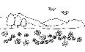 | (B) | 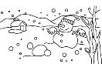 | (C) | 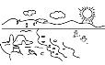 | (D)
12. | ( ) | (A) |  | (B) |  | (C) |  | (D) | 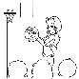
13. | ( ) | (A) | 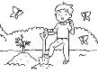 | (B) |  | (C) |  | (D)
14. | ( ) | (A) | 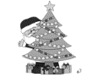 | (B) |  | (C) |  | (D) | 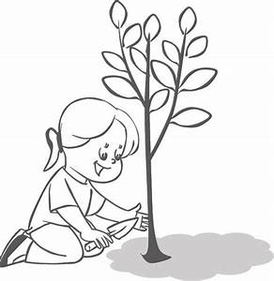
F、Listen and Choose仔細聽，選出符合對話內容的答案 (每題2分，4%)
( ) 15. (A) It’s cool in Taiwan in fall. (B) It’s warm in Taiwan in fall.
(C) It’s hot in Taiwan in fall.
( ) 16. (A) Yes, they do. (B) No, they don’t. (C) Yes, I like PE.
( ) 17. What subject does Bob like?
(A)He likes Chinese and English.
(B)He likes PE and English.
(C)He likes art and music.
G、 Listen and Choose看圖，聽辨對話內容並回答問題(每題2分，8%)
( ) 18. What’s the season now?
- Spring. (B) Summer. (C) Winter.
( ) 19. Is it hot there in spring?
(A)Han: Yes, it is. (B) Mulan: No, it isn't. (C) Han: No, it isn't.
( ) 20. Han’s hometown(家鄉) might be …
- Beijing (北京) (B) Taipei (C) Singapore

21. | ( ) | A: What sujects ______ he like? B: He art.  (A) do; like (B) does; like (C) does; likes
22. | ( ) | hot in Taiwan in summer.  (A) I’m (B) It’s (C) We’re
23. | ( ) | A:What's _________ favorite season?  B:Our favorite subject is music. (A) your (B) my (C) their
24. | ( ) | A: How can we save the Earth? B: .  (A) We can go swimming. (B) We can make a toy car.  (C) We can reduse, reuse and recycle trash.
25. | ( ) | A: I can’t do my math homework.  B: . I can teach you.  (A) What’s wrong? (B) Don’t worry. (C) I’m sorry.
第二部分：閱讀理解與寫作測驗，共五十分
H、Grammer and Reading 文法選擇與閱讀 (每題2分，10%)

I、Read and Copy 看圖並回答問題(26~29) (每題2分，8%)
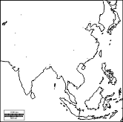
Tokyo: 5° C
Kaohsiung: 25° C
Shanhai: 15° C
Singapore: 35° C
Spring, 2020

: Thank you for tuning in Come Love worldwide weather report.
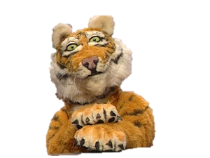
We'll checking the weather all over east Asia with Tim Tiger. First, Tokyo.
:How's the weather in Tokyo? : It's ___________ .
Word bank:
hot warm
cold cool
:Is it __________ in Kaohsiung in spring? : Yes, it is.
:Is it __________ in Singapore in summer, too? :Yes, it is.
:How's the weather in Shanhai:? : It's ______________ .
- :Well, thank you for tuning in Come Love worldwide weather report.
- Let's see you next time.
J、 True or False讀一讀，並根據內容填答True”T” or False ”F” (每題2分，10%)
( ) It's always(總是) cloudy in spring.
( ) It's hot in Taiwan in summer.
( ) It's always(總是) rainy in Fall.
( ) We wear jacket in Fall.
( ) We go shopping in winter, epecially before the Chinese New Year.

K、 Read and Choose看圖表找資訊 (每題2分，6%)
Mike
Nick
Rick
(A)
Hi, my name is Mike. I'm ten years old. I am a student. _____ father is an astronout
And my mother is a singer. My best friend is Nick. ______ brother is ten years old too.
They are twins(雙胞胎). ___________ parents are teachers.

(每題2分，6%)

(B) Students of classes 601 votes for their favorite subjects. Look at the chart and answer the questions.

33.( ) What is the favorite subjects of the Class 601?
(A) English (B) Math (C) PE
34.( ) How many students like PE?
(A) Three (B) Four (C) Five
- ( ) What’s the second popular subjects ?
(A) Math, art and social studies
(B) Music, art and social studies
(C) Math, English and Chinese

L、 Reading 閱讀並回答問題 Go green and love the earth
April 22 is the earth day. People around the world hold rallies(集會), conferences(研討會) and outdoor activities to claim their ideas to save the earth. As children you can’t go protesting(抗議) or raise a conference, but what can you do? Check the bellow action and make a choice! (每題1分，4%)

□ Save water | □ Turn off lights.
□ Take public transports | □ Clean the local beach 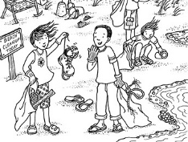

M、Read,and Write讀一讀，看圖並寫出單字(每題1分，6%)
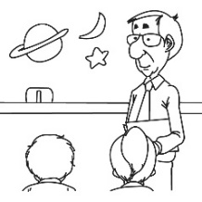 nsciece | 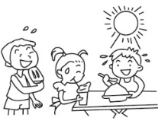mersum
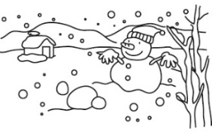 ntwire | 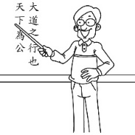 Cshenie
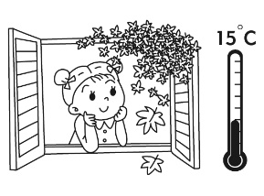 oocl | 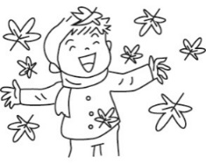 lafl
第四部分：口說能力測驗，共10分
N、Oral Test 口說能力測驗(10%)※已於平時施測，將一同併入段考成績。

