Christmas desserts around the World
Figgy Pudding 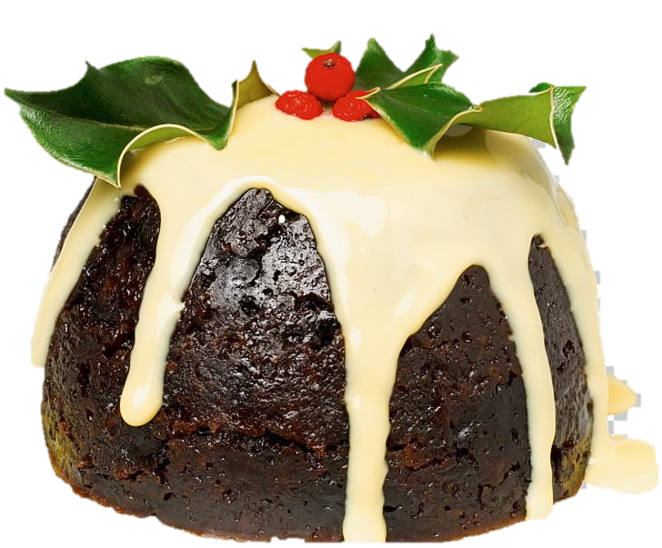
A traditional dessert for Christmas celebrations is more like a cake than a pudding. Charles Dickison’s famous novel ”A Christmas Carol” also mentioned the climactic moment while the gourmet being presented. The traditional recipe included thirteen dried fruits and grains, like raisin or currents, which is represented the 12 apostles and Jesus Christ. Next time, when you chant the famous Christmas Carol “We wish you a Merry Christmas”, don't forget proudly ask the demand “Now bring us some figgy pudding😀”!
因知名的聖誕頌歌”We wish you a Merry Christmas”而家喻戶曉的”Figgy pudding ”「 無花果布丁」，其實主要的成分是乾果、穀類、蛋及麵包塊，加上家人濃濃的祝福而製成！與其說是布丁，還更像是蛋糕。在傳統的耶誕大餐中，它可是最後登場的重頭戲喔！
Britain
sa
英國
聖誕美食探秘
With the coming of the polar vortex and the chilly air it brings, and the Christmas carols people chanting on the street, that all reminds us “ Christmas is on the way!” Christmas is a traditional holiday in most western countries. It aims to celebrate the birth of human’s savior Jesus Christ. There are varieties of way people celebrate the holiday, especially ultimate on the food or dessert people take during the holidays. Let’s take a look!
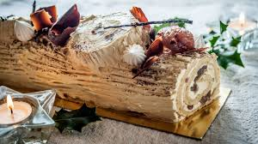
BÛCHE DE NOËL (Yule Log Cake, 聖誕木柴蛋糕)
It‘s origin from a Nordic tradition. Yule is the name of the old Winter Solstice festivals in Scandinavia and other parts of northern Europe, such as Germany. People will prepare a huge log in the house and keep the house warm. The log will burn at least the 12 days of the Christmas holidays. Nowadays people use rolled sponged cakes filled with jam or cream, covered with buttercream instead.
France 法國
聖誕木柴蛋糕源自於斯堪地納維亞慶祝冬至結束的傳統。人們會準備一大段木頭拖至室內燃燒以保持屋內溫暖。中世紀後法國等中歐國家會在整個聖誕節期間12日燃燒這段木頭。後來則以其形狀代替，成了餐桌上令人愛不釋手的美味佳餚囉!

The origin of the candy cane is about a choir leader who wants to keep the young singers quiet during the Christmas service, he asked the candy maker made the cane shape hard candy. The color red represents the blood of Jesus Christ, white means the purity of the Savior Lord. 小朋友，在享受這些美味食物的同時，也別忘記聖誕節帶給我們的終極意義喔！ Merry Christmas and Happy New Year!

