|  |
| --- |
| 測驗說明: 1. 範圍：康軒Hello Kids第四冊Lesson4~ Festival:Dragon Boat Festival 命題教師:林嵐婷 2. 本次評量總分為口說(10分)+筆試(90分)，口說評量於平時施測，將一併列入本次評量。3. 本試卷共2頁，依序為聽力、閱讀與寫作三大部份。一、聽力測驗：第1大題至第4大題，共30分，請聽測驗CD內容，依題意選出一個最適答案。每個選項將會念2次。二、閱讀及寫作能力測驗：第5大題至第9大題，共60分，每題只有一個正確的答案，依題意選出一個最適合答案。三、口說能力測驗，10分 4. 本試卷成績滿分90分，所有答案應求字體工整清楚，如有模糊不清或錯別字，兩字扣一分。 |

花蓮縣康樂國民小學一O八學年度第二學期四年級英語科期末評量(筆試)

班 級： 四 年 班 　 號 　 姓名：\_\_\_\_\_\_\_\_\_\_\_\_ Name(英文名字):  **\_\_\_\_\_\_\_\_\_\_\_\_\_\_\_\_**

**第一部分：聽力測驗，共三十分**

**1 Listen & Circle** 圈出聽到的字首音 (8%)

1. v f 2. l r
2. th有聲 th無聲 4. r l

**2 Listen and Number**依聽到的順序標上編號(9%)

|  |  |  |  |  |  |  |
| --- | --- | --- | --- | --- | --- | --- |
| 1 |  | 35 |  | 45 |  | 55 |
| 2 |  | 20 |  | 30 |  | 40 |
| 3 |  |  |  |  |  | \\163.20.172.3\derstop7$\yawenl\桌面\kitchen-isometric-line-art-vector-34883147.jpg |

1. **Listen, Read and Circle**聽一聽問題，圈選出答案(8%)

|  |  |
| --- | --- |
| wp13-3  **Micky** | D:\1032HK4修訂\電腦命題系統\HK4 轉檔May\HK4習作 wmf\HK4習-7.wmf  **Amy** |
| This is how I brush my teeth do therefor im spingebob | Spongebob9:30  **Bob** | **Mr. Lion** |

1. Micky Amy

2. dining room living room

3. doing her homework doing his homework

4. bedroom bathroom

**4 Listen & Choose**聽CD，選出正確句子 (6%)

1. ( ) (a) They’re in the dining room.

(b) They’re in the bedroom.

(c) They’re in the living room.

2. ( ) (a) It’s eleven twenty-five.

(b) It’s eleven thirty-five.

(c ) It’s eleven forty-five.

3. ( ) (a) Where is he?. (b) Where are they?

(c) Where’s Daddy?

**第二部分：閱讀及寫作測驗，共六十分**

**5 Read & Choose** 選出正確答案 (10%)

　1. ( ) \_\_\_\_\_\_\_ six o’clock. .

(a) It’s (b) It (c)This

2. ( ) A: Where \_\_\_\_\_\_ Judy?

B: She’s in the kitchen.

(a) am (b) is (c) are

3. ( ) A: What time is it?

B: It’s twelve twenty.

(a) 2:12 (b) 12:20 (c) 12:12

4. ( ) A: What time is it?

B: It’s \_\_\_\_\_\_\_\_\_\_\_\_\_\_\_\_\_\_\_\_\_.

(a)eight thirty-five

(b) eight forty-five

(c) seven forty-five

5. ( ) Where \_\_\_\_\_ Judy and Candy?

(a) are (b) is (c) am

**6**  **Unscramble the word** 拼出正確的單字 (10％)，每題二分

|  |  |
| --- | --- |
| 1. | 描述: 四格線_8cmorfty → 40 |
| 2. | 描述: 四格線_8cm描述: 四格線_8cmwetnty-ivef 25 → - |
| 3. | 描述: 四格線_8cmtirhty → 30 |
| 4. | 描述: 四格線_8cm kcithne → |
| 5. | 描述: one4描述: 四格線_8cmnoe → |

**7**  **Look and Write** 看圖，依提示填入正確的答案(24%)

What Where time doing is are brushing his teeth doing the dishes doing her homework bedroom bathroom She I fifty forty eight nine seven

living room

|  |
| --- |
| 1. |

**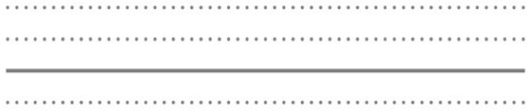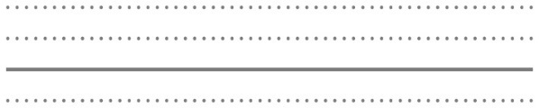** 1. It’s .

**** What is Sherry ?

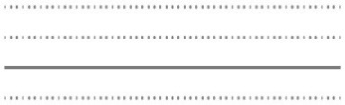is **.**

|  |
| --- |
| 2. |

**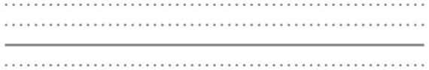**2.A: What is it?

**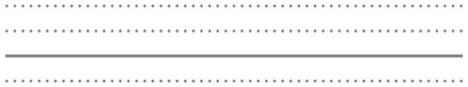**

B: It’s eight .

**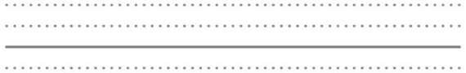**

A: is he?

**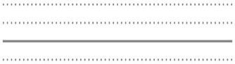**B: He in the .

**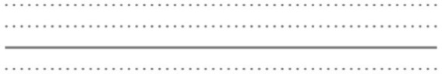**A: is he doing?

****B: He is .

**8 True or False** 根據圖片在括弧內寫上

T(True對的)或F(False錯的) (10%)

|  |  |  |
| --- | --- | --- |
|  | **Activity** | **Room** |
| 1**1.**  Andy | sp31-2 |  |
| **22.**  Betty | sp31-5 |  |
| **33.**  Cindy | sp31-3 |  |
| **44.**  David | ãeatingãçåçæå°çµæ |  |

1. ( )Andy is doing the dishes in the kitchen.

2. ( ) David is eating in the dining room.

3. ( )Betty is doing her homework in the living room.

4. ( ) Andy is brushing his teeth in the bathroom.

5. ( ) Cindy is doing the dishes in the kitchen.

**9 Unscramble the sentence**

請重組句子，重新寫在格線上 (6%)

1. Mom / cooking / the / . / is/ in/ kitchen

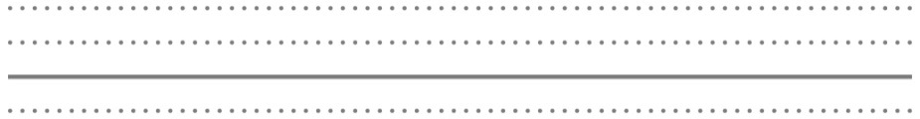

2. for / ! / you/ This/ is



小朋友，寫完記得要多檢查幾遍喔!

